
Academic Year 2026-27 ( ODD SEM)
DEPARTMENT OF ARTIFICIAL INTELLIGENCE AND DATA SCIENCE
Project Based Learning Minor Project 1
One Page Project Report
Title: AI-Driven Vulnerability Index Mapping for Districts in Maharashtra to El Niño Droughts Using Socio-Economic and Climatic PCA
Project No. 12
Guide: Prof. Pankaj Deshmukh
Sr.No. | Roll No. | Name of Student
1 | 34 | Tanishq Mewada
2 | 47 | Saad Patel
3 | 48 | Peeyusha Patki

Introduction: El Niño years often bring a weak monsoon and drought to Maharashtra, but how badly a district is hurt depends on how much it relies on rainfed farming and how well it can cope. This project builds a relative El Niño drought vulnerability index for 34 districts of Maharashtra. Two El Niño rainfall indicators, derived from 75 years of IMD gridded rainfall and NOAA's Relative Oceanic Niño Index (RONI), are combined with four agricultural and socioeconomic indicators from the Census 2011 and the Agriculture Census. Principal component analysis (PCA) gives the indicator weights, K-Means clustering groups the districts into Low, Medium and High vulnerability, and the result is checked against government drought declarations and shown in maps and an interactive Streamlit dashboard.
Objectives:
1. To collect and integrate official district-level climatic and socioeconomic data for Maharashtra, and to derive El Niño-specific rainfall indicators from 75 years of IMD rainfall and NOAA's RONI.
2. To construct a PCA-weighted composite El Niño drought vulnerability index on a 0 to 100 scale for 34 districts.
3. To classify the districts into Low, Medium and High vulnerability groups with K-Means clustering, and to validate the results against Government of Maharashtra drought declarations.
4. To present the index and groups through district maps and an interactive Streamlit dashboard.
Flow diagram:
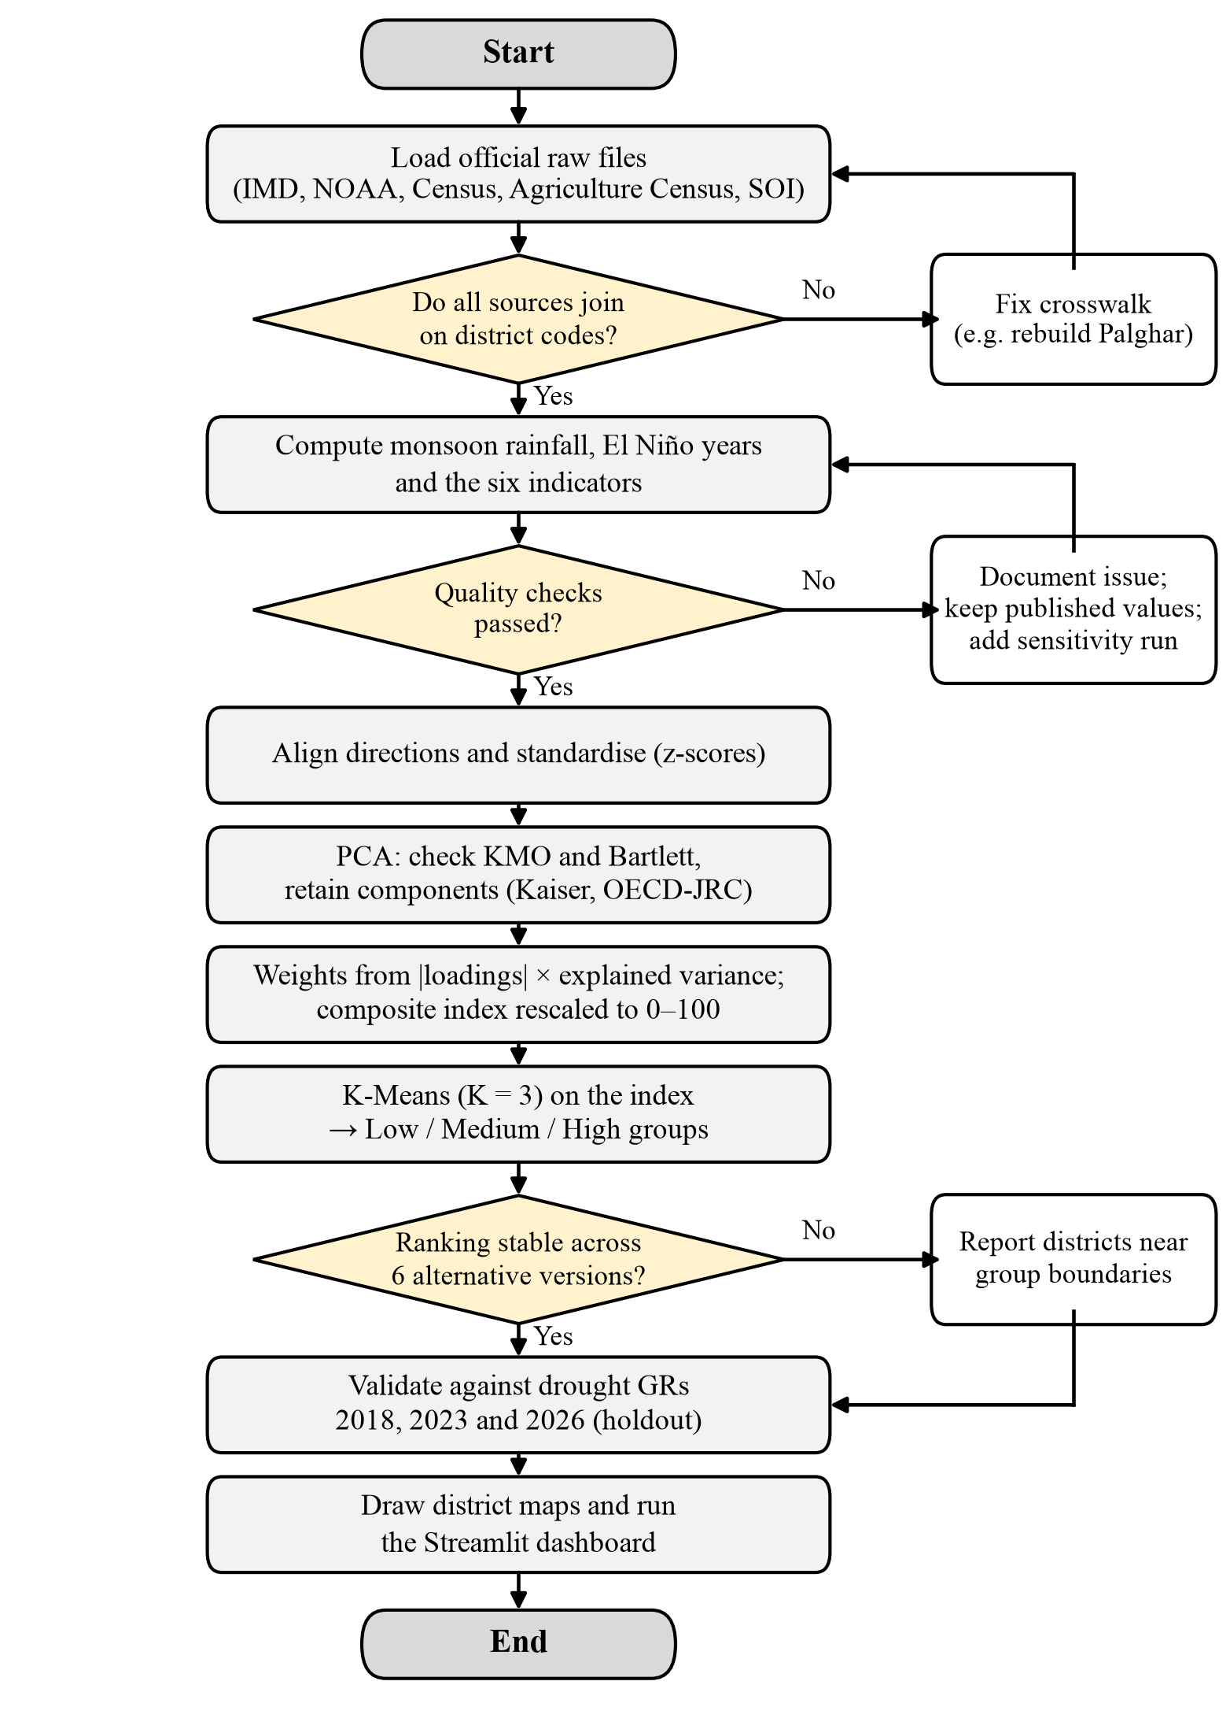
Software:
1. Programming language: Python 3.12
2. Data handling and statistics: pandas, NumPy, SciPy, xarray, netCDF4
3. Machine learning: scikit-learn (StandardScaler, PCA, K-Means)
4. Maps and dashboard: GeoPandas, Matplotlib, Streamlit
5. Development tools: VS Code, pytest, Git, GitHub.
Conclusion: The project gives a transparent and reproducible ranking of El Niño drought vulnerability for the districts of Maharashtra. Vulnerability is highest in Marathwada and the dry interior, where El Niño rainfall losses meet rainfed farming and lower literacy: 10 districts are in the High group, 20 in Medium and 4 in Low. The index agrees moderately with the drought declarations of 2018 (Spearman ρ = 0.585), 2023 (0.450) and 2026 (0.545), and it can support drought preparedness planning when an El Niño is forecast.
References:
[1] D. S. Pai, M. Rajeevan, O. P. Sreejith, B. Mukhopadhyay, and N. S. Satbha, "Development of a new high spatial resolution (0.25° × 0.25°) long period (1901–2010) daily gridded rainfall data set over India and its comparison with existing data sets over the region," Mausam, vol. 65, no. 1, pp. 1–18, Jan. 2014, doi: 10.54302/mausam.v65i1.851.
[2] NOAA Climate Prediction Center, "Relative Oceanic Niño Index (RONI), ERSST.v6." [Online]. Available: https://www.cpc.ncep.noaa.gov/data/indices/RONI.ascii.txt (accessed Sep. 27, 2026).
[3] D. Swami and D. Parthasarathy, "Dynamics of exposure, sensitivity, adaptive capacity and agricultural vulnerability at district scale for Maharashtra, India," Ecol. Indic., vol. 121, Art. no. 107206, Feb. 2021, doi: 10.1016/j.ecolind.2020.107206.

